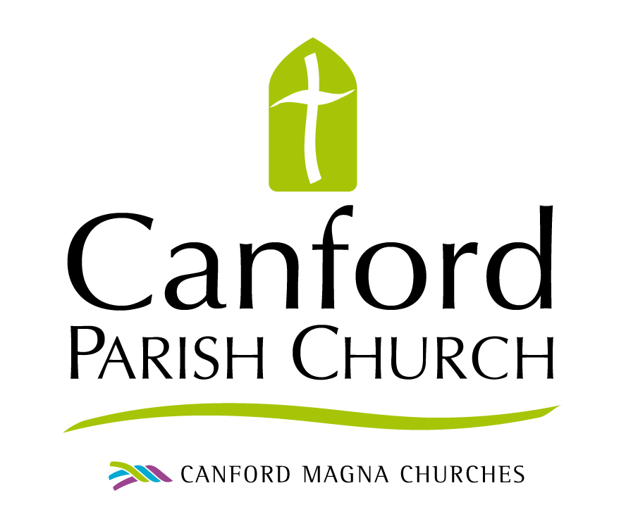

September 13 – October 4, 2020
Life Group Study Notes

Introduction
As we begin a new phase after the summer with the COVID 19 pandemic, over the next four weeks we’ll be reflecting on where the Spirit is leading us all personally, where he is leading the church and what implications that has for our local, national and worldwide communities.

To aid us in our discernment we will be focussing on just one verse of Scripture (although there will be companion readings for each week. That Scripture is Jeremiah 6:16.

This is what the Lord says:
Stand at the crossroads and look;
Ask for the ancient paths,
ask where the good way is,
and walk in it, and you will find rest
for your souls.
But you said, ‘We will not walk in it’. Jeremiah 6:16

I hope you will have some lively discussions in your Life Groups this month. It promises to be a bumpy Autumn and Winter so anything that helps to prepare our hearts and minds I think will be very helpful.

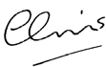
Chris Tebbutt September 2020

Recommended books / resources

Where is God in a Coronavirus World?, John Lennox, the good book company.com

The Book of Jeremiah – J Thompson Eerdmans

Index

Week 1 Stand
Week2 Look
Week3 Ask
Week4 Walk

13 September 2020 ‘Stand’ 1 Kings 19:9b-18.

Welcome

Welcome all the members to the group, especially any new ones. If you are missing any members send them a text or WhatsApp to let them know you’re praying for them. Decide who will phone them to make sure they’re okay.
Worship

Come together in worship. Ask the Holy Spirit to bless your time together. If there are prayer needs bring them before the Lord either now, or at the end of the meeting.

Word

Read Jeremiah 6:16. This is our root passage.
What strikes you about this passage?
How might it resonate with a people about to go into exile?
What are the parallels with todays COVID 19 pandemic and our situations?
What does it mean to ‘Stand’? Where else in the Bible does it tell us to stand? Are there parallels with this passage?

Read 1 Kings 19:9b -18
Elijah made a stand against Ahab , Jezebel and the prophets of Baal. Despite the victory of the Lord on Mount Carmel over the false gods of Canaan, Elijah flees to Mount Horeb. Even though we have God on our side, how is it that we sometimes lose our nerve and doubt his power to save?

The recovery happens after the Lord says to Elijah ‘Go and stand …’ V11. What was Elijah told to do, and where do we see examples with our own lives in the earthquake, wind and fire, and the whisper of God.

Witness

Reflect on the busyness of your life.
If this is the complete opposite to your life, give thanks for the peace and ask for more opportunities to interact.

End by singing SoF 1 – 79, Dear Lord and Father of mankind
https://youtu.be/WqOnjmr9Ah0

- Dear Lord and Father of mankind,
Forgive our foolish ways;
Reclothe us in our rightful mind,
In purer lives Thy service find,
In deeper rev’rence, praise.
- O Sabbath rest by Galilee,
O calm of hills above,
Where Jesus knelt to share with Thee
The silence of eternity,
Interpreted by love!
- Drop Thy still dews of quietness,
Till all our strivings cease;
Take from our souls the strain and stress,
And let our ordered lives confess
The beauty of Thy peace.
- Breathe through the heats of our desire
Thy coolness and Thy balm;
Let sense be dumb, let flesh retire;
Speak through the earthquake, wind, and fire,
O still, small Voice of calm.
- In simple trust like theirs who heard
Beside the Syrian sea
The gracious calling of the Lord,
Let us, like them, without a word,
Rise up and follow Thee.

20 September 2020 ‘Look’ 1 Samuel 16:6-13

Welcome
Perhaps you could greet everyone over a cup of tea or coffee this evening, to try to make your virtual group feel a little more friendly and welcoming! Swap favourite recipes for cakes and biscuits! Check in briefly with one another, with the leader making notes of any prayer requests for now or later.
Worship
Come together in worship. Ask the Holy Spirit to bless your time together. Play the video ‘God I look to you’. https://youtu.be/JDx26GEcCOg

Word
Read Jeremiah 6:16 to remind us all of our root passage.
Having lived with this passage for a couple of weeks, is God speaking anything new into your heart? As we stand at the crossroads what do you see as the priority in your life and in the life of the Church?
Ask the Holy Spirit to come in power to reveal new hidden depths.

Read 1 Samuel 16:6-13 God sees things very differently to us. The media is plugging their agenda: we have to work to be smarter, more good looking, self-reliant and incredibly gifted to ‘get on’. By contrast, God wants us to ‘get off’ and tune in to his way of thinking. It’s a lot less about what we do and more about who we are in him and in relationship with others.

(1) Which particular "instructions" of the Lord's would be the most helpful to implement in our lives, the Church and the Government at this time? What "reset" do you perceive the Lord wants?

(2) How has the Pandemic affected your life - the way you think and what you do? What are the blessings you perceive God has given you in this time?

(3) Can you see opportunities and possibilities of progress, of "The New" ahead - for you, the Church and our nation?

(4) What practical things can we engage in to counter the negativity around us? What can we do to promote life?

Witness
It is very easy to become fearful during this time of pandemic; watching the news, reading the statistics on the various website, picking up bad news. Instead try to be salt and light in your personal community this week. Use the words of the song we sung earlier ‘God, I look to you’ as a prayer to help you.

God, I look to You, I won't be overwhelmed
Give me vision to see things like You do
God, I look to You, You're where my help comes from
Give me wisdom, You know just what to do
Chorus:
And I will love You, Lord, my strength (sing that out)
I will love You, Lord, my shield
I will love You, Lord, my rock
forever, all my days,
I will love You, God.

God, I look to You, I won't be overwhelmed
Give me vision to see things like You do
God I look to You, You're where my help comes from
Give me wisdom, You know just what to do.

Chorus

Hallelujah, our God reigns
Hallelujah, our God reigns
Hallelujah, our God reigns
Forever, all my days, Hallelujah.

27 September 2020 ‘Ask’ 2 Chronicles 1:1-12
Welcome
Ask your guests how their week has been. If they say, ‘fine’ press a little harder. Part of being in a Life Group is to be able to share real needs. As leader, note down specific requests for the worship time.
Worship
Come together in prayer and worship. Share the particular needs of the group as we petition and ask God for his help.
Word
Read Jeremiah 6:16 to remind us all of our root passage.
Having lived with this passage for a couple of weeks, is God speaking anything new into your heart? As we stand at the crossroads what do you see as the priority in your life and in the life of the Church?
Ask the Holy Spirit to come in power to reveal new hidden depths.
Read 2 Chronicles 1:1-12.
- (1) Chroniclesrecountsmuchofwhat1Kingscontainsbuttendsto emphasise Solomon’s good points and sanitizes his shortcomings. For example, it misses out 1 Kings 11 which was mentioned in the sermon. Why have two accounts of the same events in the Bible?
- (2) HowhadSolomonwalkedalongtheancientpathsashewas growing up? What were the signs of the connection with these paths? (vv3-6)
- (3) Howcanweaskbetterthewaysoftheancientpathsandhowcan the five CS’s mentioned in the sermon help discern the right path?
- (4) How can we encourage one another to pursue the ancient paths rather than ‘conforming to the ways of the world’ Romans 12:2
Growing into the likeness of Christ...
2
Witness
What hope do you see in the current pandemic for the church to help return the world to following the ancient paths? What should we be asking for?
End with this song from Songs of Fellowship 1- 493
Seek ye first the Kingdom of God
And His righteousness
And all these things shall be added unto you Allelu Alleluia
Al - le - lu - ia
Al - le - lu - ia
Al - le - lu - ia
Al - le - lu Al - le - lu - ia
Ask and it shall be given unto you Seek and ye shall find
Knock and it shall be opened unto you Allelu Alleluia
Karen Lafferty © 1972 CCCM Music

4 October 2020 ‘Walk’. Matthew 14:25-33
Welcome
What’s been the most inspiring thing you’ve read about or seen this week?
Worship
Come together in prayer and worship. How can we learn to walk in the ways of the Lord in all we say and do? Listen to the worship song ‘Oceans’ which was the response song on Sunday to Chris’ talk. https://youtu.be/ga3DmPRPAQQ
Word
Read Jeremiah 6:16 to remind us all of our root passage.
Having lived with this passage for a couple of weeks, is God calling you to walk on a different path to the one you’ve been on?
1) What do you see as the ancient paths or practises we should be following?
Read Matthew 14:25-33
This reading is all about confidence and courage. Walking in ancient paths means stepping out in faith and often taking a different path to that which is comfortable and safe.
- 2) Why does Jesus come to the disciples walking on the water?
- 3) What inspires Peter to step out of the boat?
- 4) Does Jesus let Peter sink? Or is it Peter’s lack of faith?
- 5) What can we all learn from this passage?
- 6) Share with the group when God’s taken you out of your comfort zone to follow a call or ministry. Were you blessed or not?
Witness
How do you think you and our church should change to be walk more boldly in ancient practices?

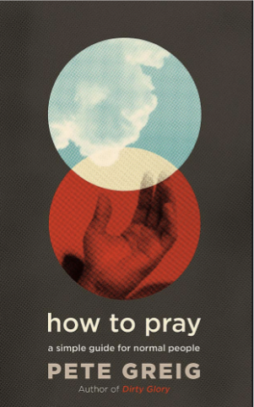
Growing into the likeness of Christ...
Preparation for next week
The ancient path of prayer underpins all the activity of the early church and results in growth. Encourage your group to go deeper in their prayer life and consider purchasing the book that goes with this series which is Pete Greig’s ‘How to Pray – a simple guide for normal people’.
You can order online from Aslan Books, or Eden Books or, of course Amazon! Shop around for the best deal.

