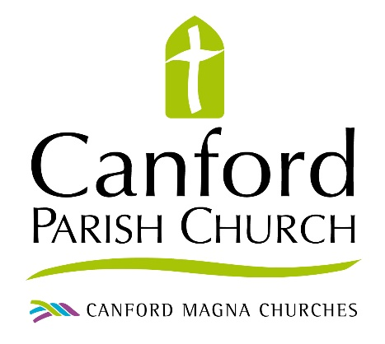 present
&

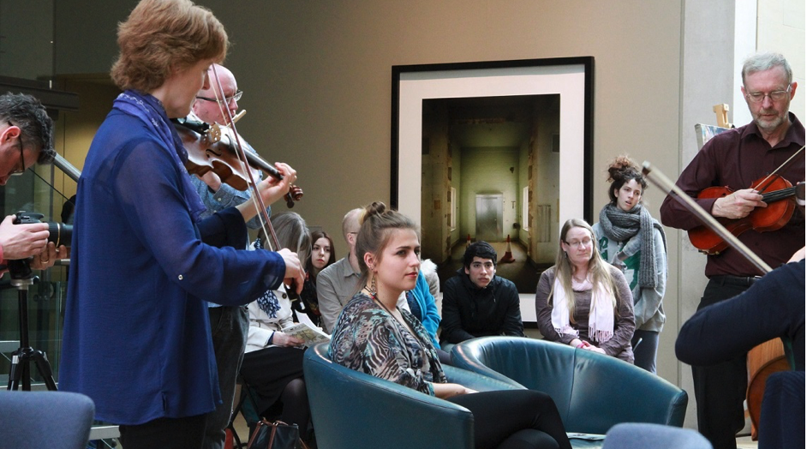

Saturday 4 May

‘Sound portraits’ and

‘A Happening’

at the

Canford Magna Centre

Sunday 5 May

Sunday Worship at 10:30

Canford Magna Parish Church

Do come – and bring your friends!

Further details overleaf

Saturday 4 May

10 am – 1pm Sound Portraits

A morning of improvised and Holy Spirit led musical portraits by Epiphany for individuals. See here for more:

http://epiphanymusic.org.uk/sound-portraits

6 pm – 8pm A Happening
In the evening the group will lead ‘A Happening’, a fluid time of improvised Spirit-led music, art and response.
Epiphany use their gifts to create a space for the Holy Spirit to work in an extraordinary way.
Epiphany’s prophetic ministry is about creating environments through music where God can meet people in powerful ways. These moments can be significant points in people’s journey of faith.

Sunday 5 May

10:30 am Sunday morning worship

Epiphany will lead the music at our Sunday morning worship. There will be more opportunity to respond to their prophetic ministry within the context of our Sunday praise and worship.

Visit our websites

Canford Magna Parish Church – www.canfordparish.org
Epiphany – www.epiphanymusic.org.uk

