Who’s Who
Diocesan Safeguarding Adviser [DSA]
Mr Jem (Jeremy) Carter
Safeguarding Adviser
Safeguarding
01722 411922, 07469 857888
jem.carter@salisbury.anglica
- Based at Church House, Salisbury
- Works 9am-5pm Mon/ Tue/ Wed; and Thu morning each week

Church Safeguarding Leads
Mrs Tracey Black: Parish Safeguarding Officer 01202 897184
- Based at The Lantern Church, Merley
- 01202 887733 safeguarding@canfordparish.org

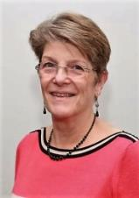 | Mrs Jane Hazell: Parish Safeguarding Officer 01202 889065  - Based at Canford Parish Church, Canford Magna  - 01202 882270 safeguarding@canfordparish.org
Mrs Tina Waterman: Parish Compliance Administrator
- Based at St Barnabas Church Bearwood
- 01202 579562 stbarnabas@canfordparish.org

